Draw a DFA for the language accepting strings ending with ‘abb’ over input alphabets

∑ = {a, b}

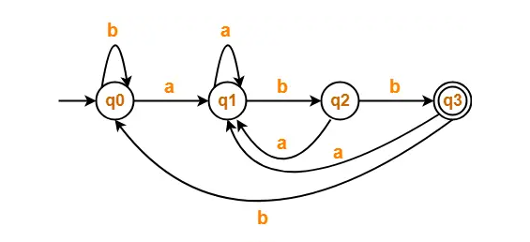

|  |  |
| --- | --- |
| **Valid strings** | **Invalid strings** |
| abb | babab |
| aabb | aba |
| ababb | babab |
| abbabb | epsilon |
| babababb | babab |

Draw a DFA for the language accepting strings over an alphabet Σ={a,b} that accepts the string starting with ‘ab’.

|  |  |
| --- | --- |
| **Valid strings** | **Invalid strings** |
| abb | babab |
| abbb | aab |
| ababb | babab |
| abbbb | epsilon |
| ababab | babab |